Idea 1)
Leveraging Randomness to Create Art



Yes, you can see an animation. Guess what, it is implemented using quantum measurement. We have implemented a quantum circuit of small depth that choose pixel states based on measurement outcome of that circuit. We are injecting randomness to create artwork.

Implementation Details :inside all_process.ipynb file
Idea : Define state with little images,dynamically choose the states based on circuit measurement result we are selecting states for each cell. The red – green color scheme is taken from our national flag.

-----------------------------------------------------------------------------------------------

Idea 2)

Medical Image Processing with exponential speed up

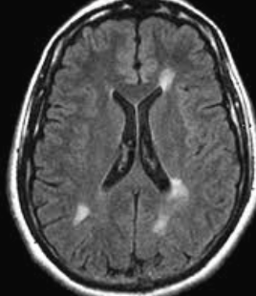
Picture : Input MRI vs MRI evolving over time

Idea : Given a MRI image, convert it into circuit ,I mean encoding it,then apply unitary operation to simulate evolvement over time with parametarized circuit,then turn evolved circuit into picture.This picture will be matched with a reference image to decide whether the input MRI will transform into a certain state/disease or how likely (% possiblity) the diseases will infect brain.

Effectiveness : In quantum circuit qubit can be in superpostion resulting all possible evolution in superposition. We can apply descision oracle simultaneously over all image I mean qubit.Because qubit holds image information.We can bruteforcing all possiblities in reasonably fast time because of superposition and single pass into the descision oracle.

Implementation : Added a function inside given quantumblur library.

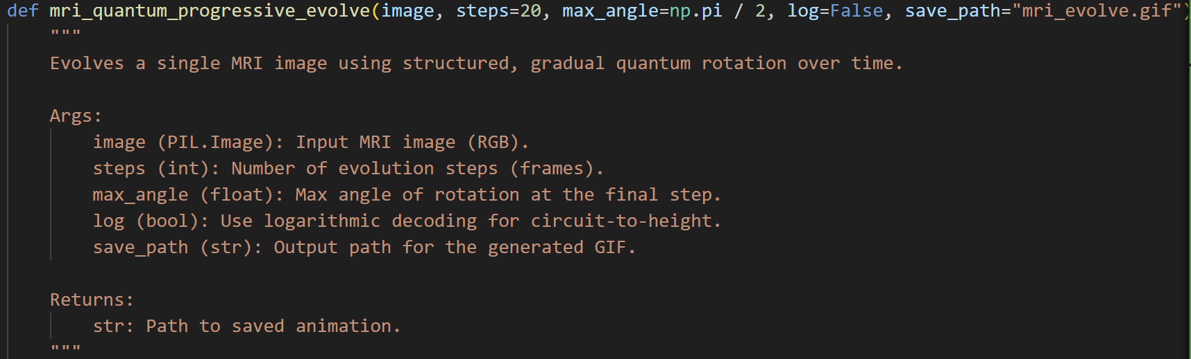
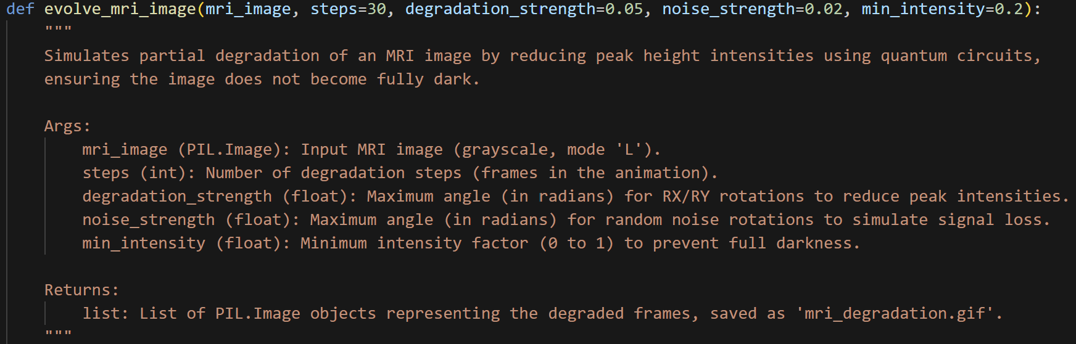
Tried different time of random evaluation, but medical evolvement is possible with designed parameterized circuits.

Idea 3)
Turn Quantum Circuit into Reality
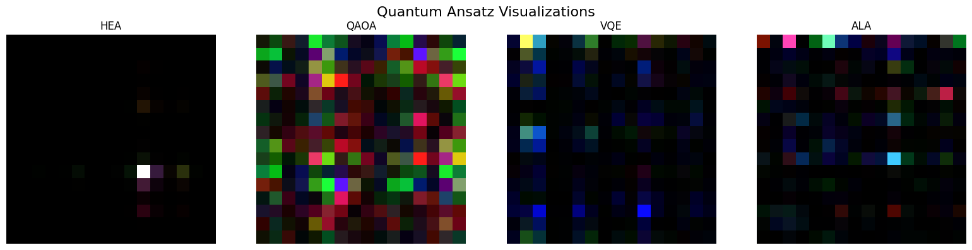
Idea: We are using different types of ansatz circuits which is turned into image using the provide library.
What is exceptional here? Each ansatz gives unique image under a fixed image generation protocol. So, we can create QR code using this that will uniquely identify some inside parameters.
Another use can be visualization the variation in ansatzes. You can consider this as a unique artwork. Also, we can reverse engineering to make ansatz from images which is useful for VQE algo.

Implementation : Added this function inside library
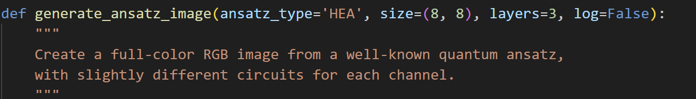

Idea 4)
Photoshoping
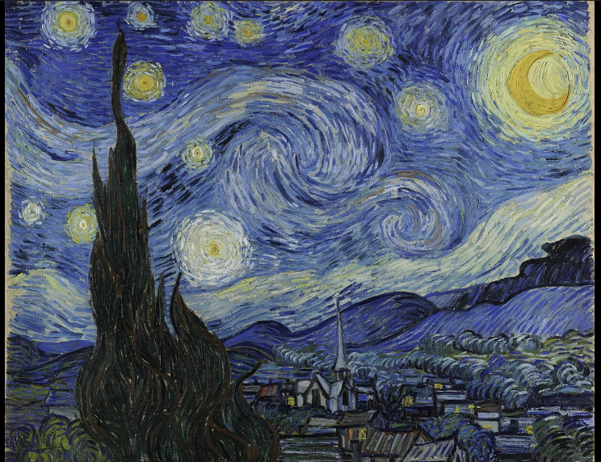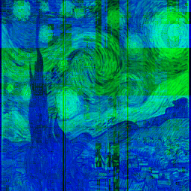

Idea : Applied some rotation gates on Green and Blue part after RGB batch encoding pipeline keeping red intact. Using similar idea we can develop masks and filters.

Implementation: indside library added a new function
qb.apply_rgb_rotations(bc,np.pi/2,np.pi)

Idea 5)
Photo Merging and Blending

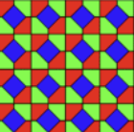 + 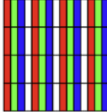 = 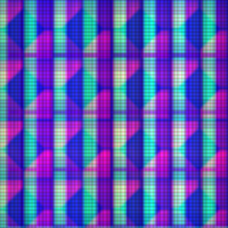
Process : Based on two input image, we create a blend version of these images.
We applied RGB batch encoding, merge R of one image with G of another image and for B starting with fresh Blue we applied some rotation gate, finally decoded image.

Implementation : 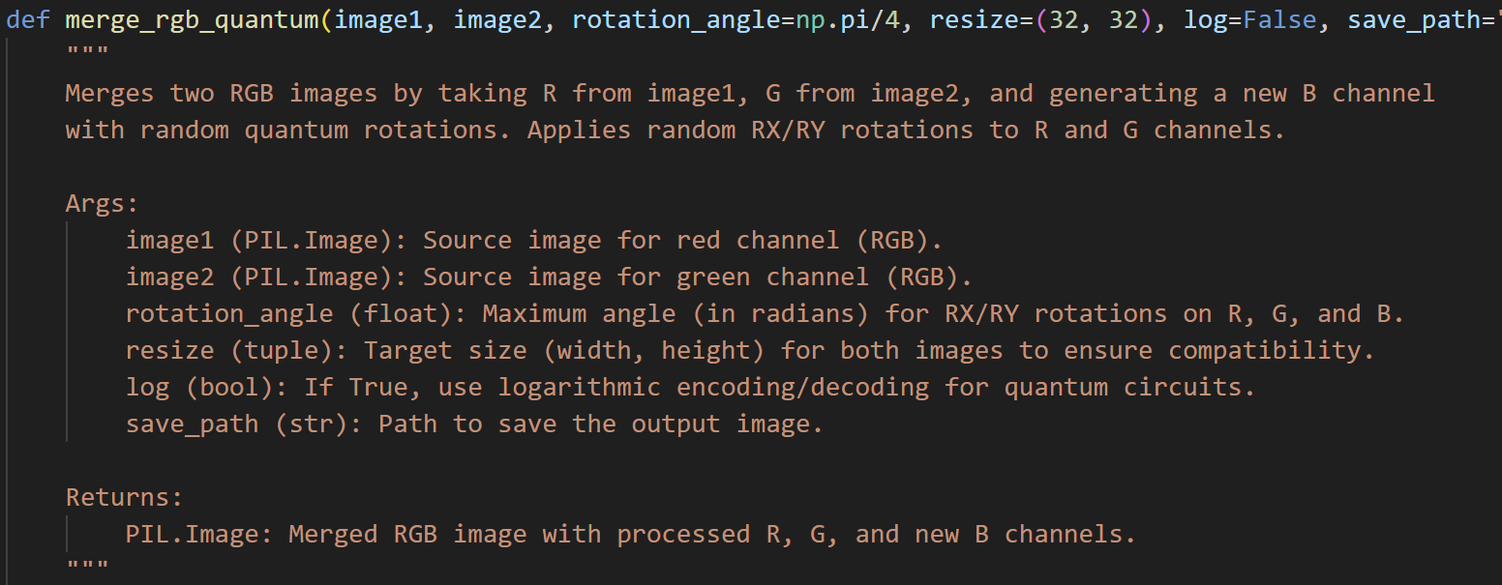
Experiment with various image on the same scheme : 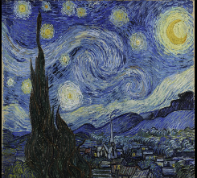 
Reference Image: (https://sites.google.com/view/poulomisarkerpuja/home ) Taken his permission for using this images.So all rights reserved. @

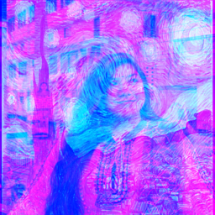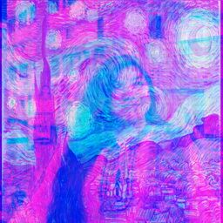
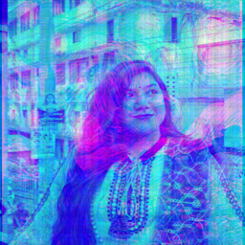

These are results of blending reference images.

Idea 6:
Simulating “Quantum Image” Degradation


Idea : Gradually added noise conditionally applying some phase gates to simulate how image can evolve noisy over time or on explored to real environment .
Implementation:
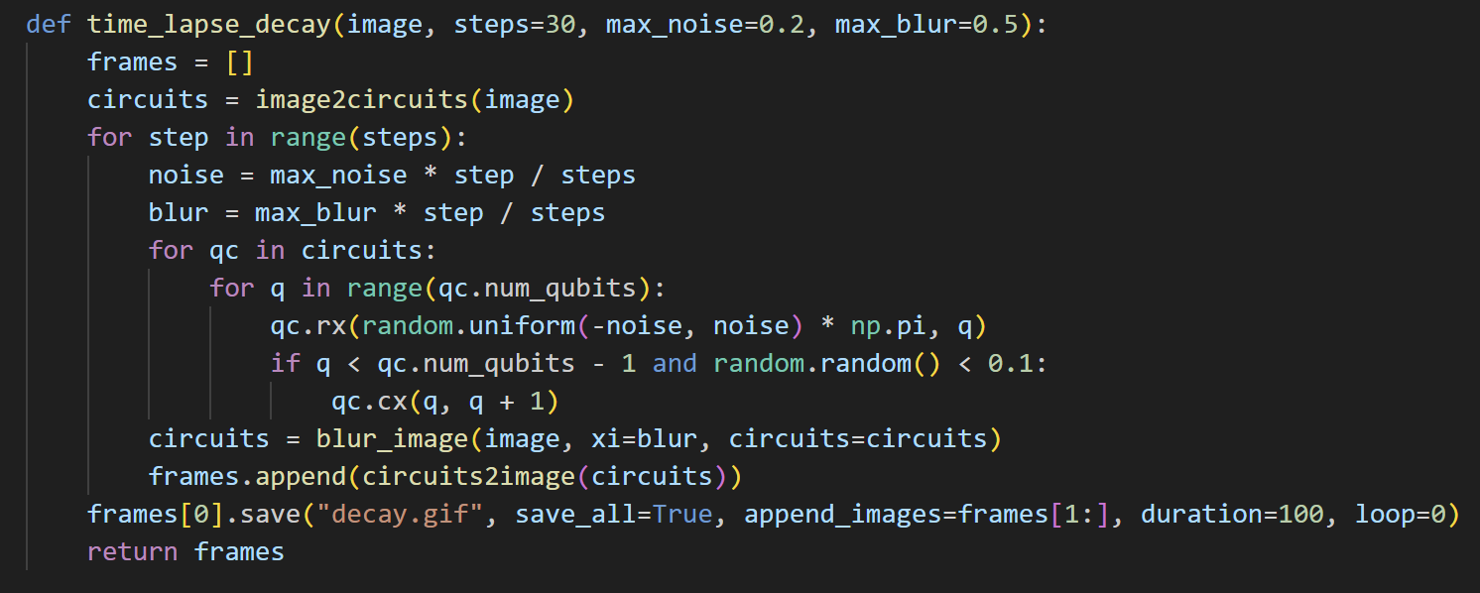

Conclusion :
Played around quantum algorithm and library given, learned a lot of new things, explored a different quantum application field. This was a nice hackathon indeed.
Thanks for arranging such an event.

With Regards,

Niloy Kumar Mondal
Undergrad CSE Student
Bangladesh University of Engineering and Technology
Email : 2105044@ugrad.cse.buet.ac.bd
Personal Contact : niloy12101001@gmail.com
Team Leader of QuittCat

